Output mock-ups

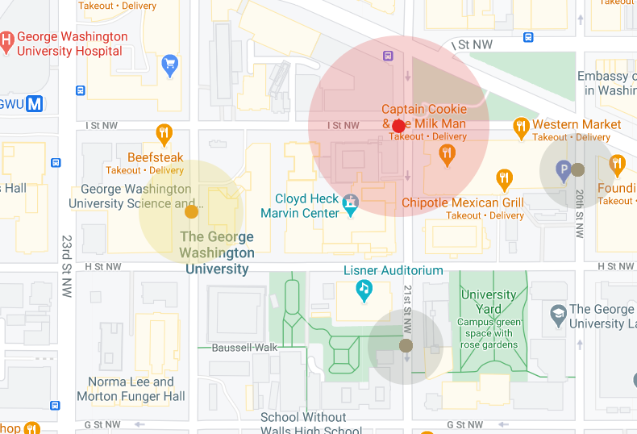

Figure 1: Desired Map output

Colour and radius size indicates recency – as time elapses color changes from red to yellow to grey in a gradient and radius decreases.

The map should be centred on the users location (search location).

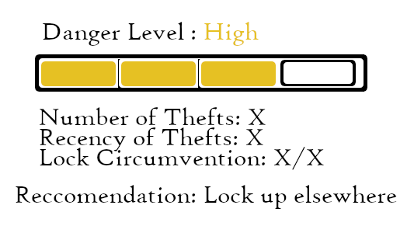

Figure 2: Recommendation Output

Bar rating the danger level

Breakdown (basic) of factors leading to the decision, and output the recommendation

*Uncertainty level indication?*

City facts

*Display city trends in bike thefts*

Thefts per year

Most thefts from one location

Most/least dangerous month for theft

Most dangerous day of the month (calander plot?)

State Facts

Most stolen from city

Most dangerous month

Country Facts

Most dangerous state